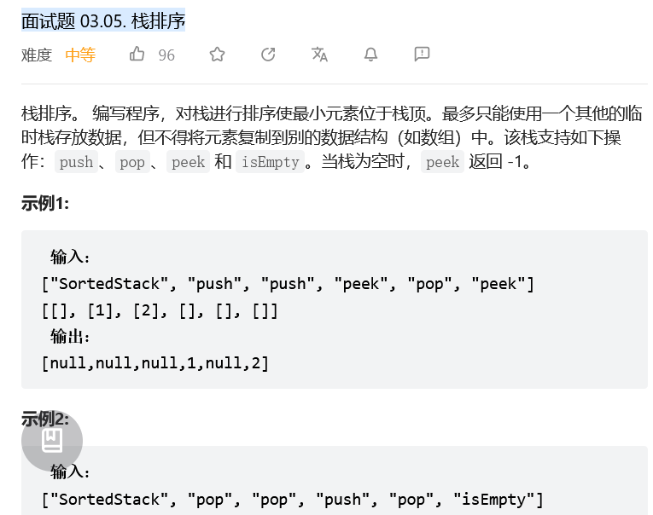

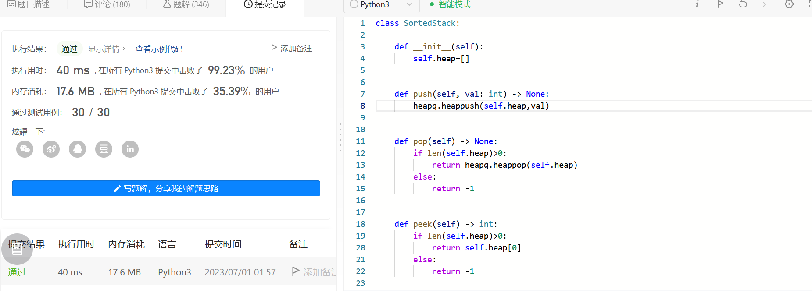
class SortedStack:

def __init__(self):
self.stack = []
self.tmp = []

def push(self, val: int) -> None:
if not self.stack:
self.stack.append(val)
else:
while self.stack and self.stack[-1] < val:
self.tmp.append(self.stack.pop())
self.stack.append(val)
while self.tmp:
self.stack.append(self.tmp.pop())

def pop(self) -> None:
if self.stack:
return self.stack.pop()
return None

def peek(self) -> int:
if self.stack:
return self.stack[-1]
return -1

def isEmpty(self) -> bool:
return not self.stack

